**Design Data Warehouses For Given Below Products**:

Note : While designing any Data Warehouse make sure to cover given below points.

a. Design Fact & Dimension tables

b. Create meaningful Primary & Foreign keys

c. Try to follow Star/SnowFlake Schema Design

d. Try to write few SQL queries to generate insightful business metrics (This is the critical

point because you need to understand the Data & Business both)

**1. Design a Data Warehouse for IPL Cricket Tournament (Asked in Flipkart Interview for Senior Data Engineer role**

**Steps to Designing a Data Warehouse**

### 1. Defining Business Requirements (or Requirements Gathering)

### 2. Setting Up Your Physical Environments

### 3. Introducing Data Modeling

The three most popular data models for warehouses are:

1. [Snowflake Schema](https://www.1keydata.com/datawarehousing/snowflake-schema.html?utm_source=xp&utm_medium=blog&utm_campaign=content)
2. [Star Schema](https://www.guru99.com/star-snowflake-data-warehousing.html?utm_source=xp&utm_medium=blog&utm_campaign=content)
3. [Galaxy Schema](https://www.folkstalk.com/2010/01/data-warehouse-dimensional-modelling.html?utm_source=xp&utm_medium=blog&utm_campaign=content)

### 4. Choosing Your Extract, Transfer, Load (ETL) Solution

### 5. Online Analytic Processing (OLAP) Cube

**OLAP Cubes vs. Data Warehouse**

A **data warehouse** is where you're storing your business data in an easily analyzable format to be used for a variety of business needs.

**Online Analytic Processing Cubes** help you analyze the data in your data warehouse or data mart. Most of the time, OLAP cubes are used for reporting, but they have plenty of other use cases

### 6. Creating the Front End

### 7. Optimizing Queries

### 8. Establishing a Rollout

1. **Design a Data Warehouse for IPL Cricket Tournament**



**Data architecture and design of Data warehouse**

A **Conical data model** (CDM) is central to this and design patterns based on a CDM

**EVENT:BUY IPL TICKET**

**THE APPROACH**

The aaproach is to follow these steps:

**Step1** –identify the events involved

**Step2**-define design psttern based on the event-dri ven conical data model

**Step3**-define a message format for the data in each event

**Step4**-define the format for loading data into the DWH for each message

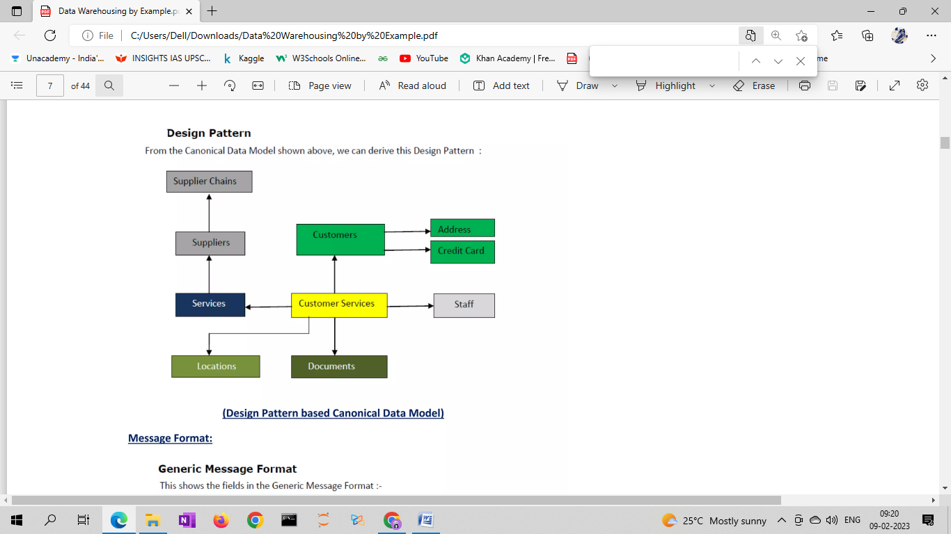

BASED ON STAR SCHEMA